WPL LAB 5
Rohan Shenoy 230905290
Roll no 32
CSE D1

DJANGO ADDITION SOLVED EXAMPLE]

OUTPUT]

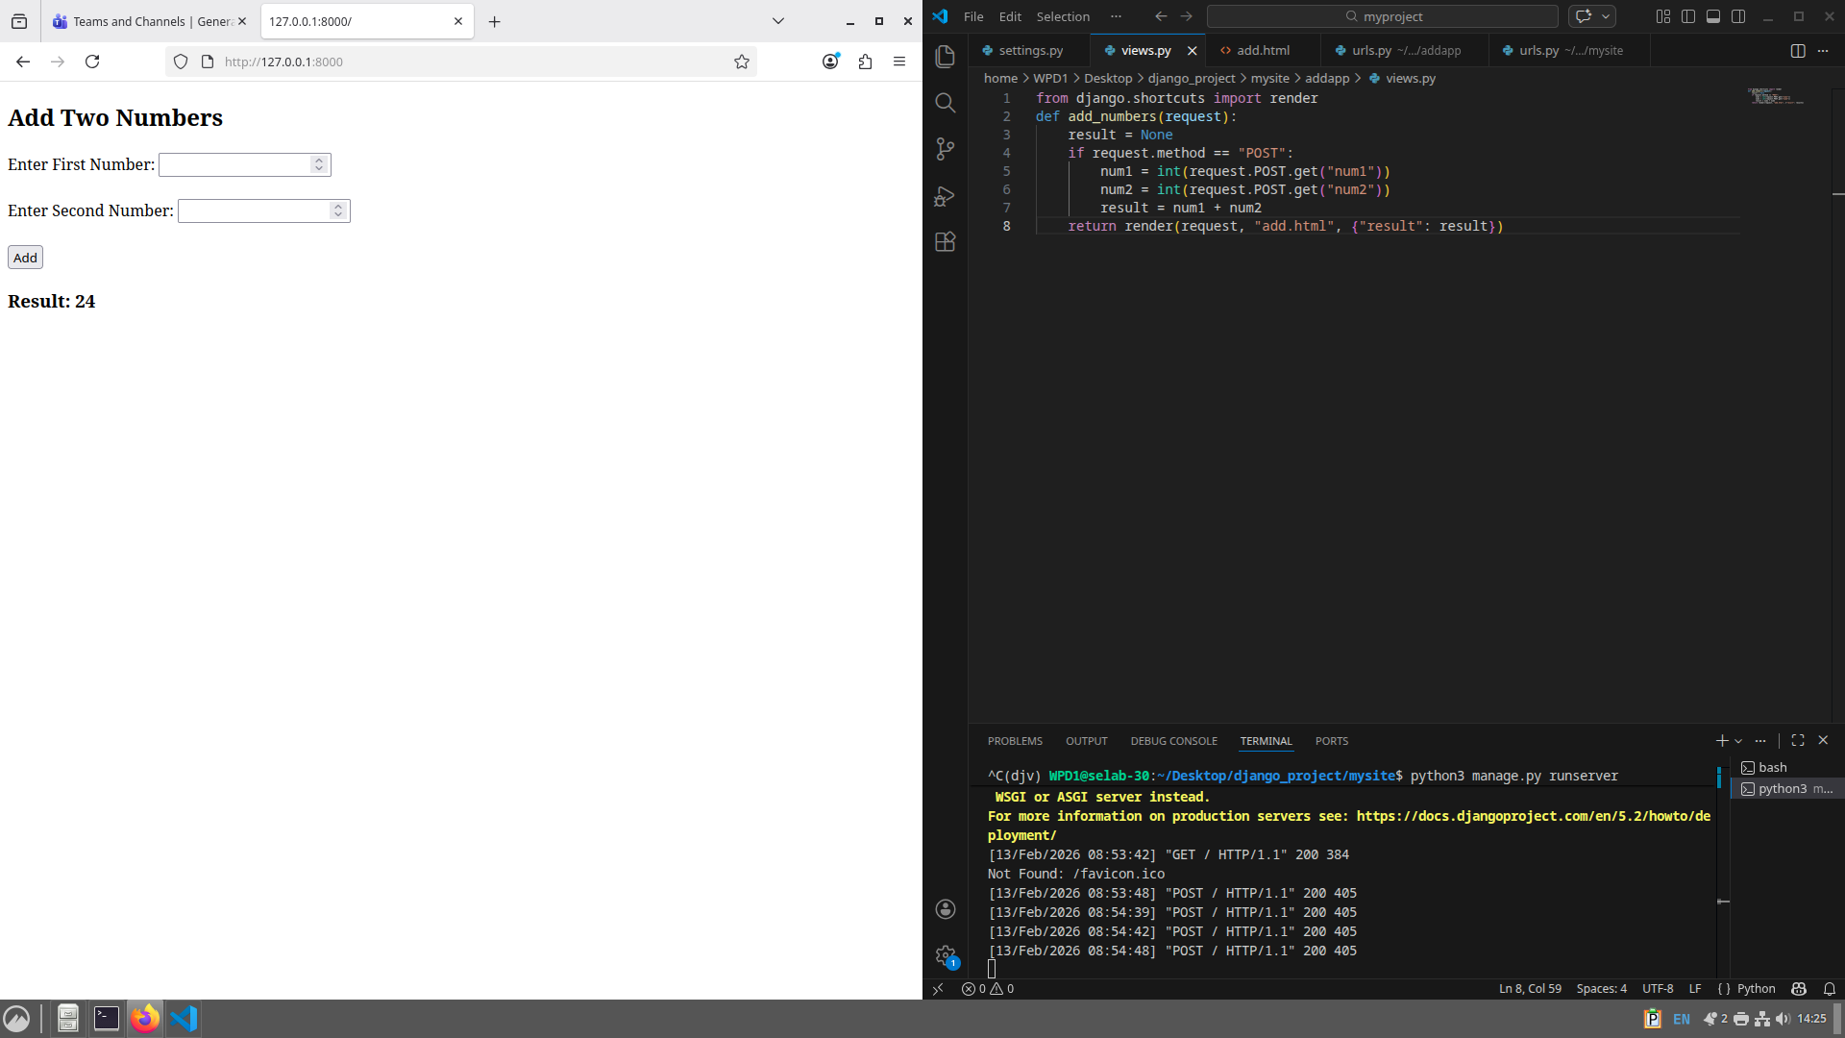

Q1] Create a web form which allows the teacher to enter the student details like name,
date of birth, address, contact number, email id and marks of English, Physics and
Chemistry. After filling all the information and on clicking submit button, details
should be added to a textarea displayed on the same page. Display the total
percentage of marks obtained in a label

OUTPUT]

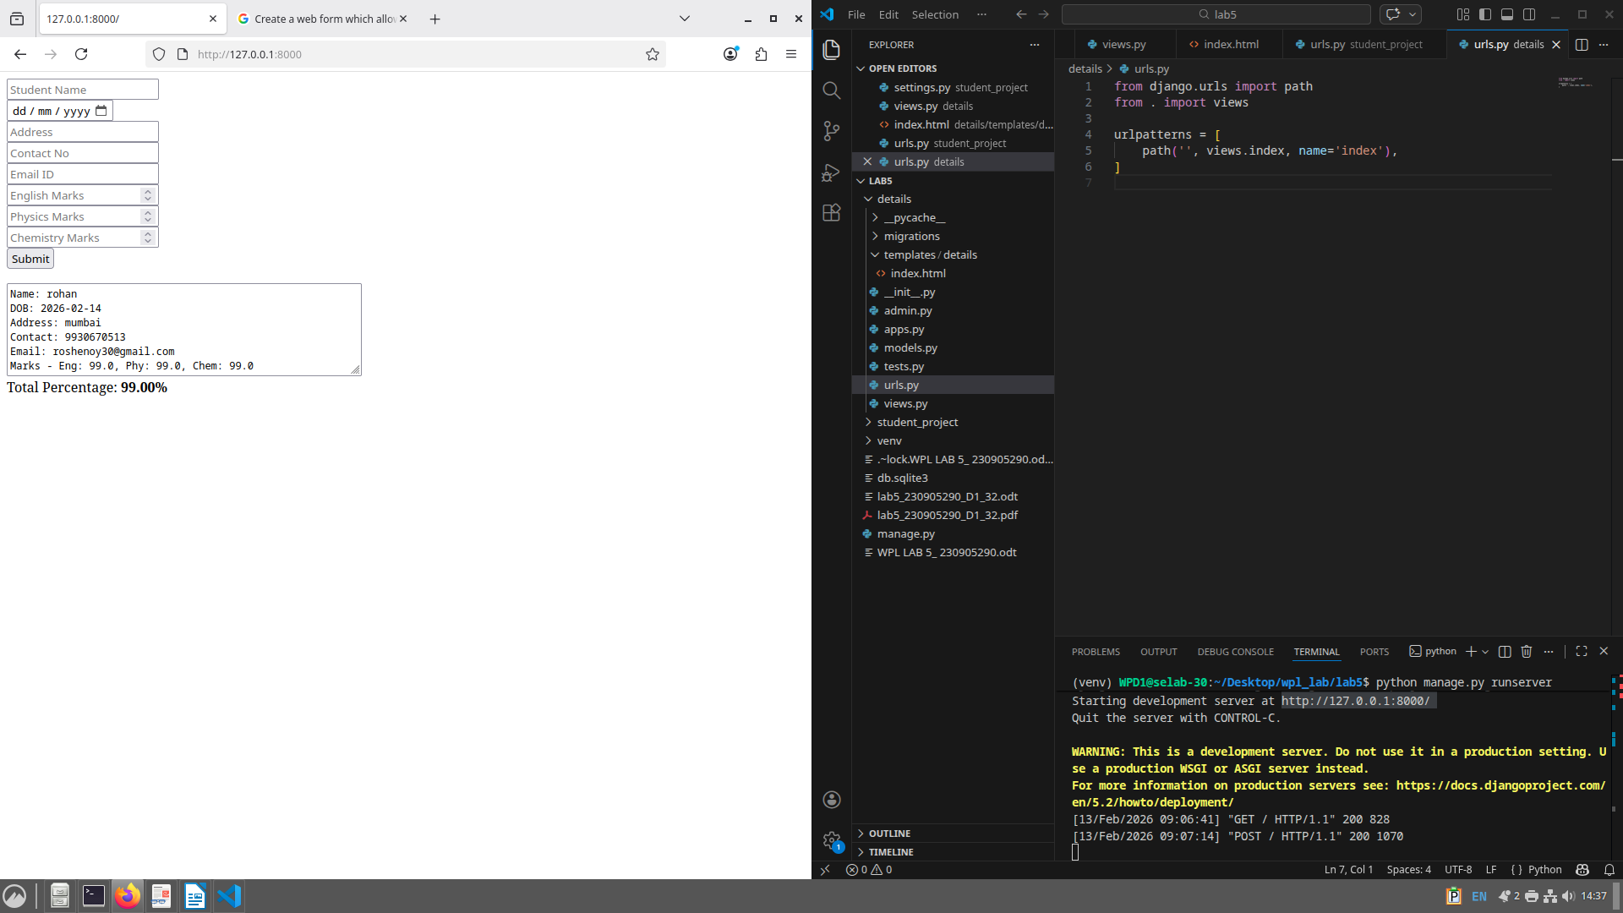

Q2] Create a web form with employee ids in dropdown list. Use a textbox for accepting
date of joining. Add a button named “Am I Eligible for Promotion”. On clicking
the button, if he has more than 5 years of experience, then display “YES” else
“NO” in the label control.

OUTPUT]

